West Virginia CBA Maps
Washington-Arlington-Alexandria, DC-VA-MD-WV
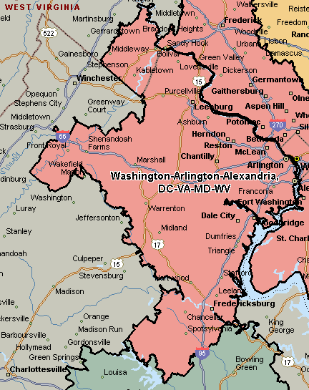
Huntington-Ashland, WV-KY-OH