Augusta-Richmond County, GA
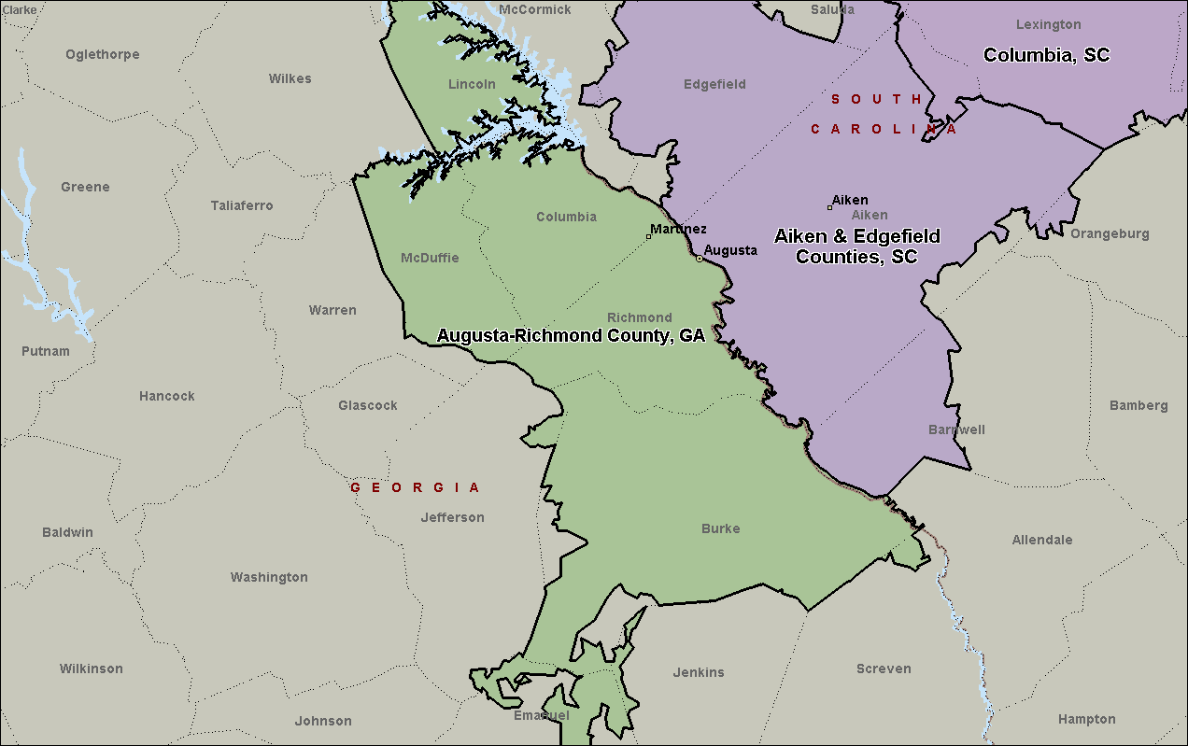

Atlanta-Sandy Springs-Roswell, GA
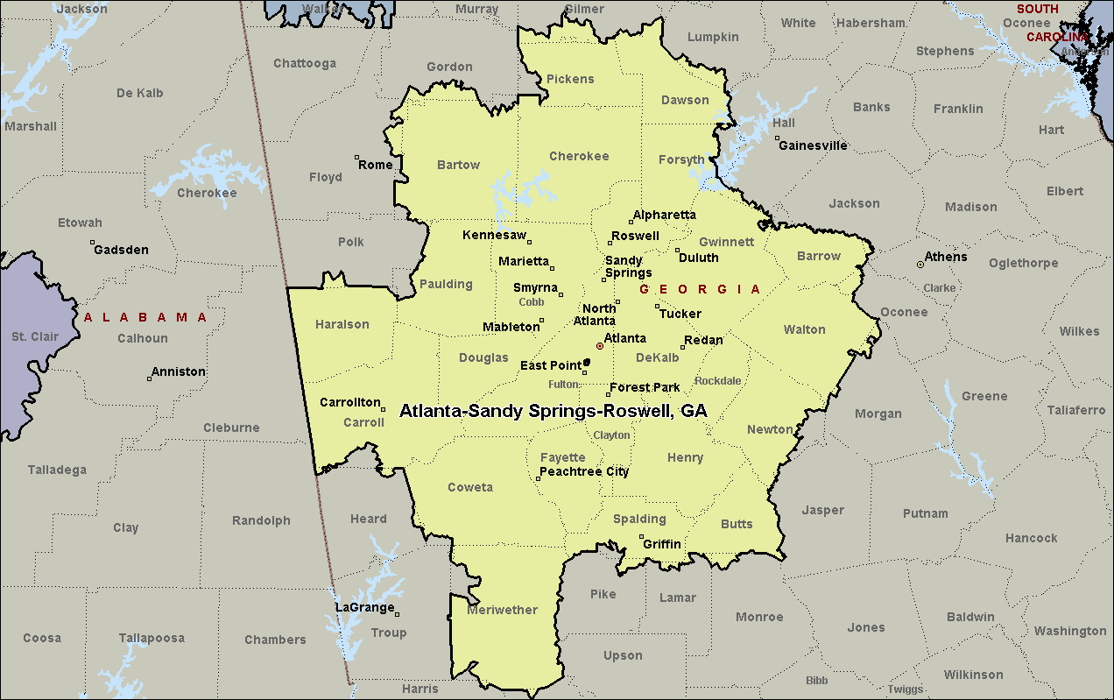

Catoosa, Dade, & Walker Counties, GA
