Massachusetts CBAs
Springfield, MA & Worcester, MA
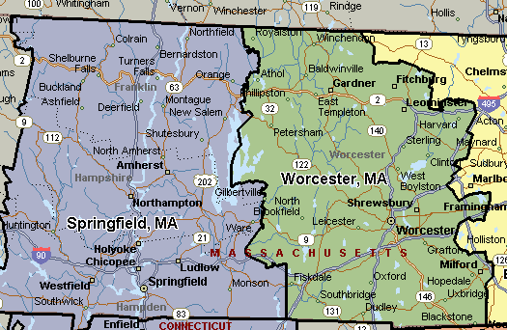

Boston-Cambridge-Quincy, MA-HA
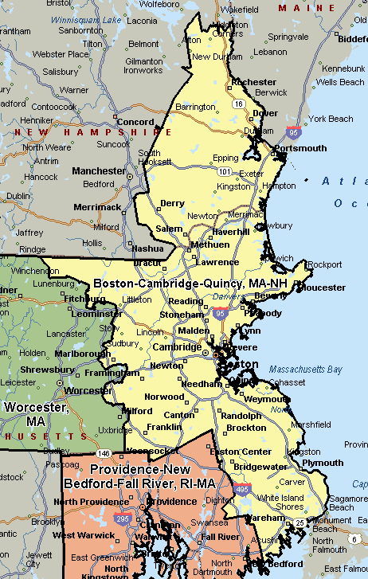

Providence-New Bedford-Fall River, RI-MA
