Washington CBA Maps

Seattle-Tacoma-Bellevue, WA
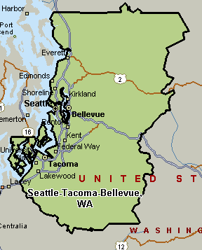

Portland-Vancouver-Beaverton, OR-WA
