**South Carolina CBA Maps**

**Charleston-North Charleston, SC**

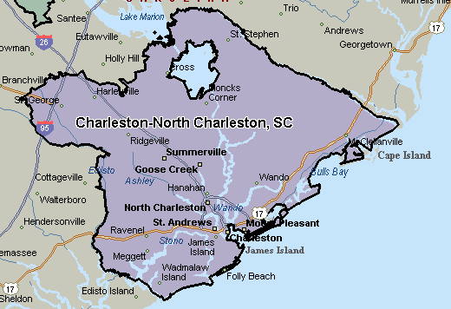

**Greenville, SC**

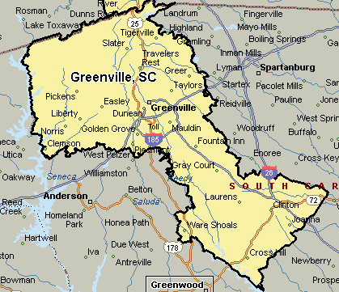

**Columbia, SC**

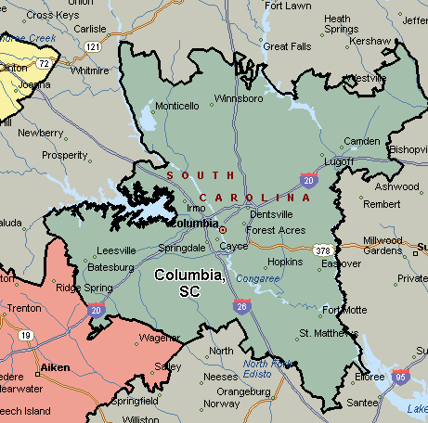

**Augusta-Richmond County, GA-SC**

