Beaumont-Port Arthur, TX

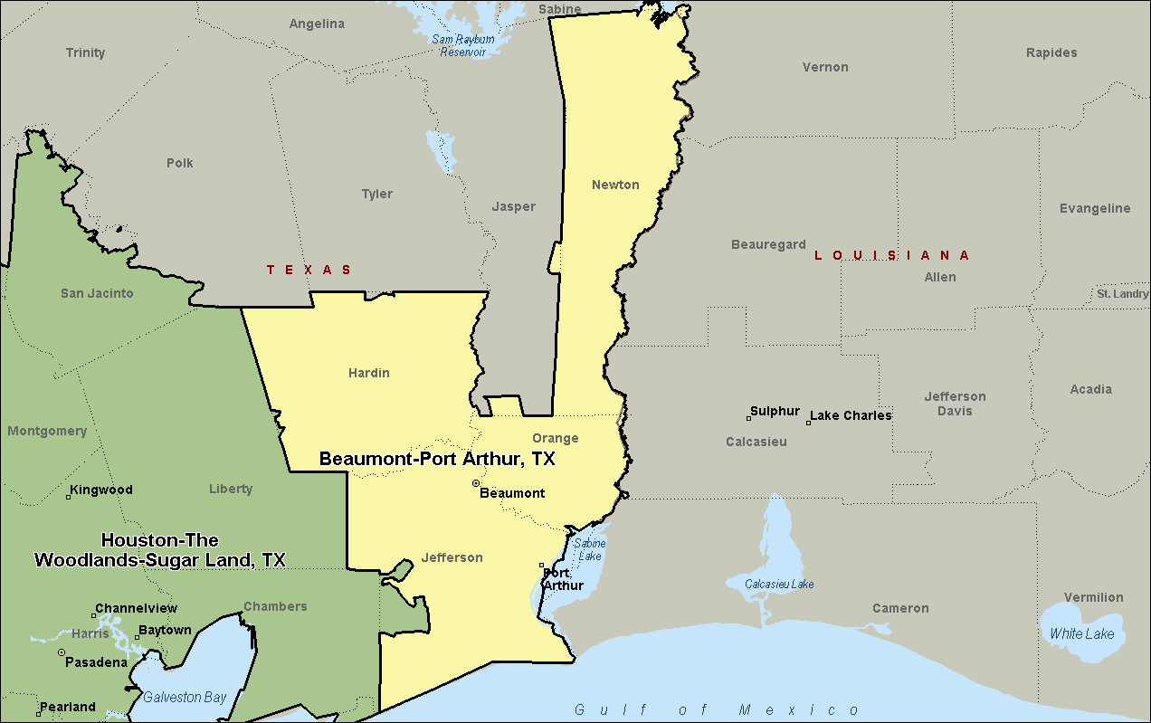

Houston-The Woodland-Sugar Land, TX

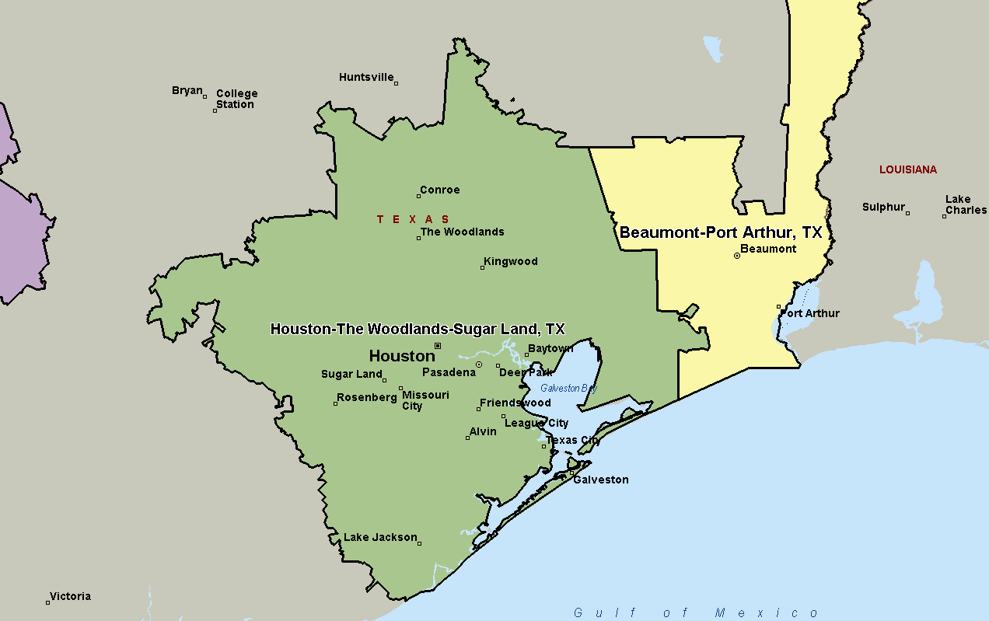

Austin-Round Rock, TX

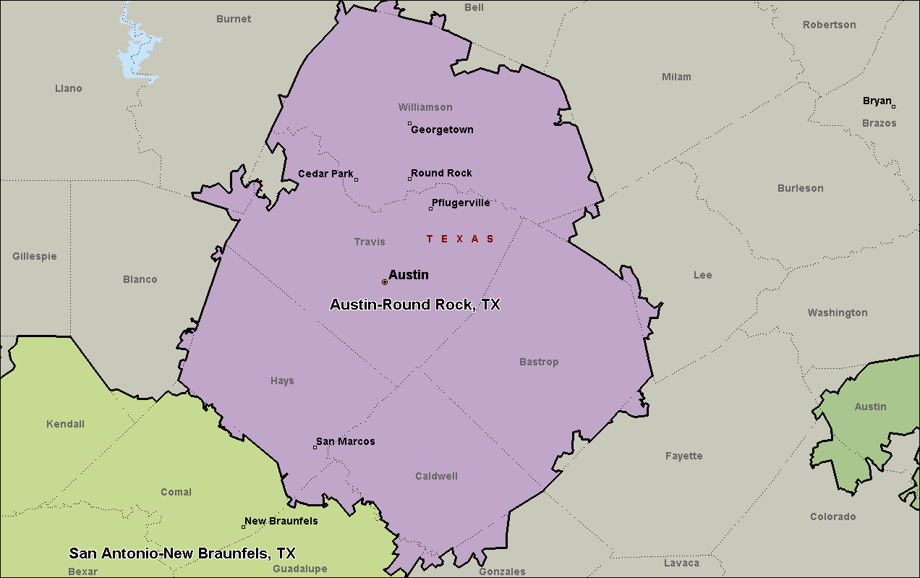

San Antonio-New Braunfels, TX

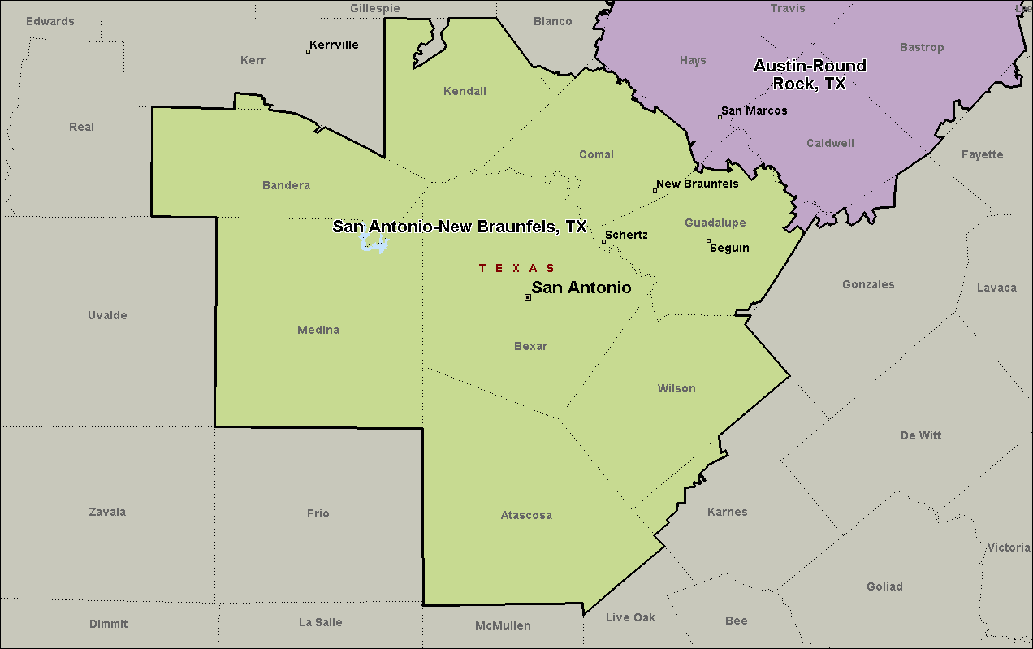

McAllen-Edinburg-Mission, TX

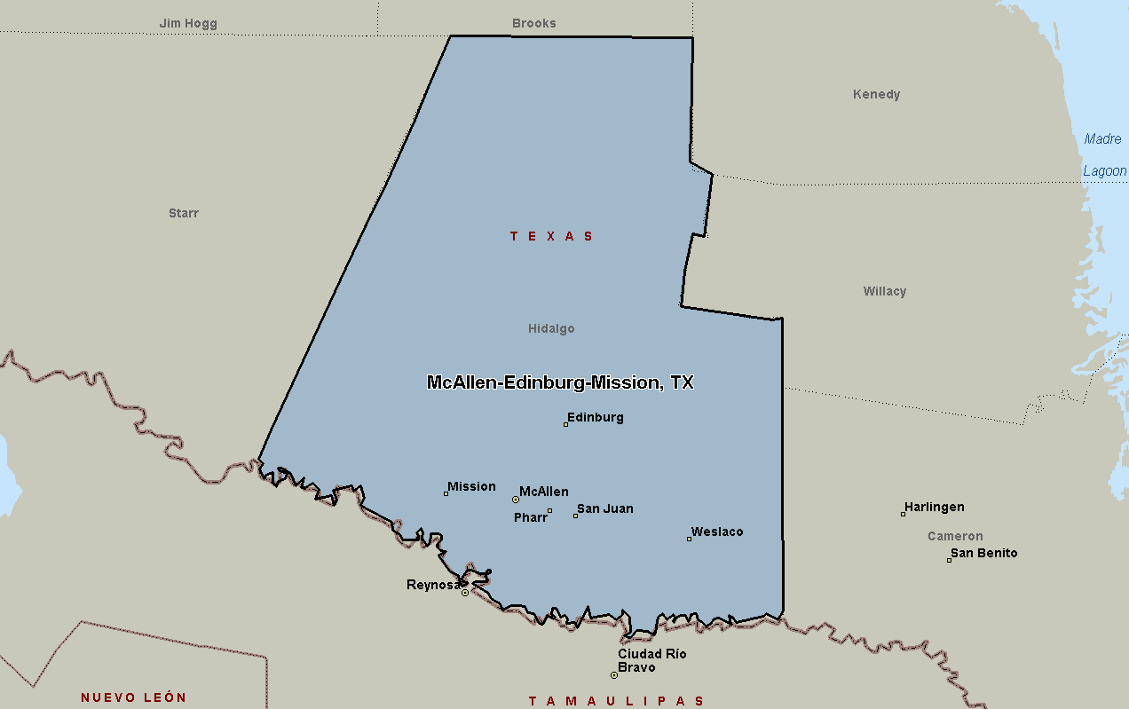

El Paso, TX

