**Seattle-Tacoma-Bellevue, WA**

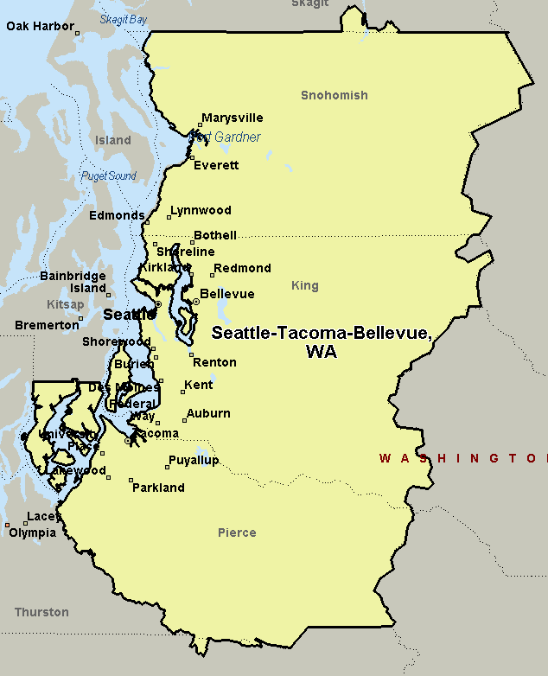

**Vancouver, WA**

