Mercer County, PA

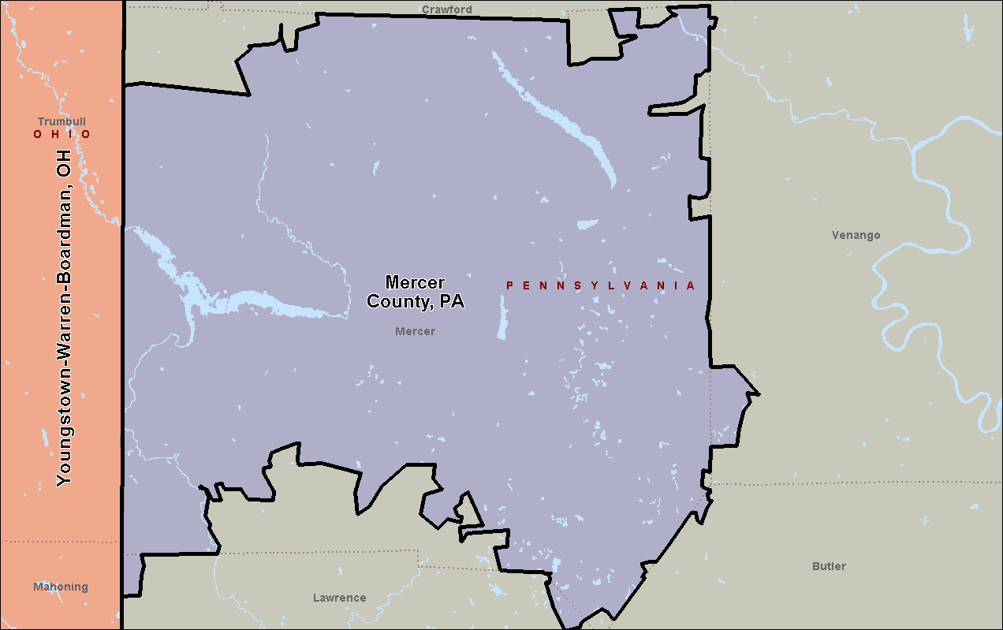

Scranton-Wilkes Barre-Hazleton, PA

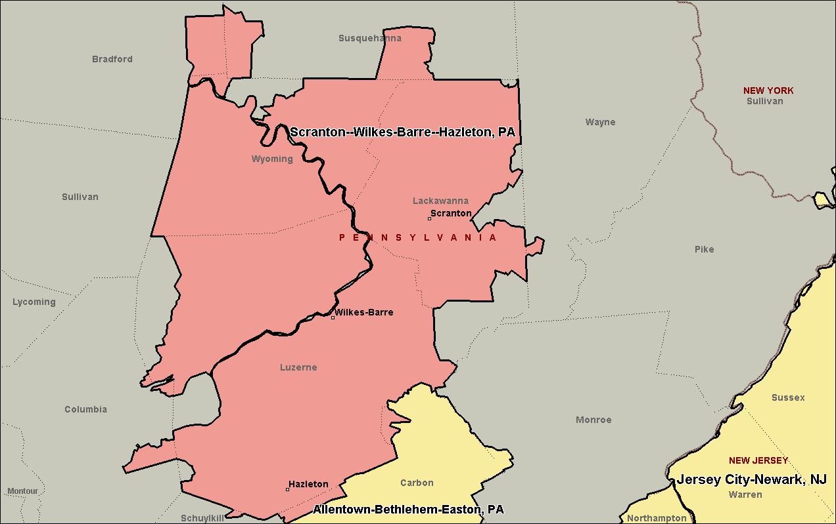

Allentown-Bethlehem-Easton, PA

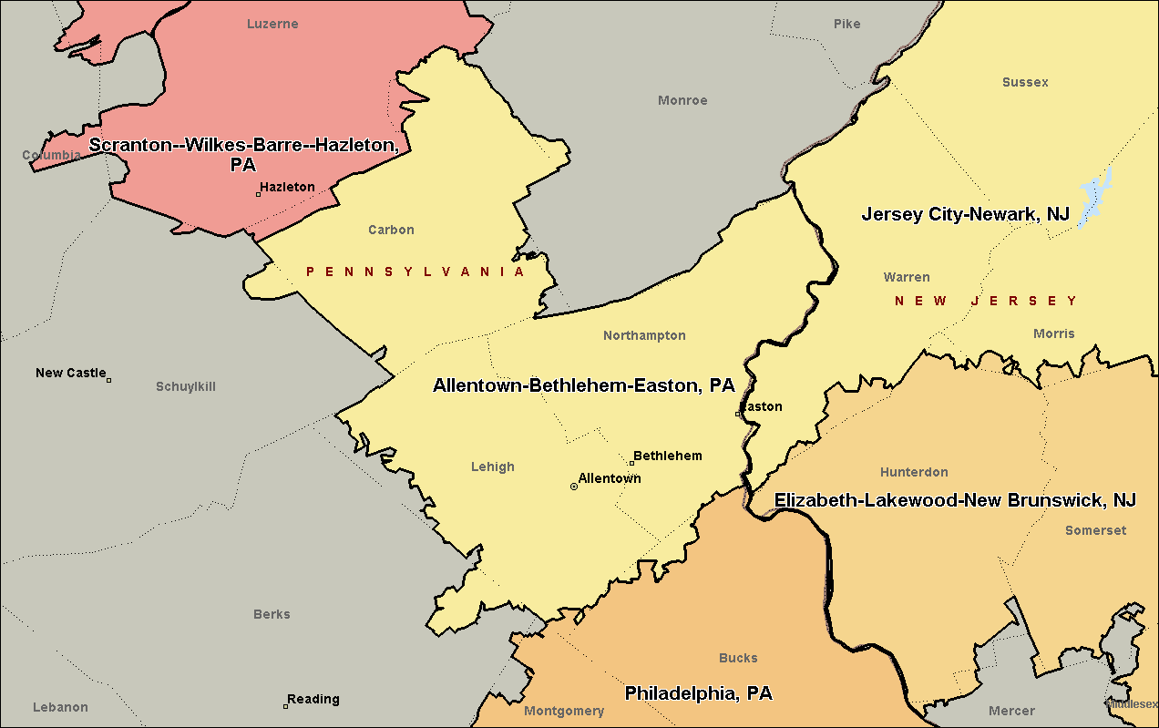

Philadelphia, PA

