Pennsylvania CBA Maps
Philadelphia-Camden-Wilmington, PA-NJ-DE-MD
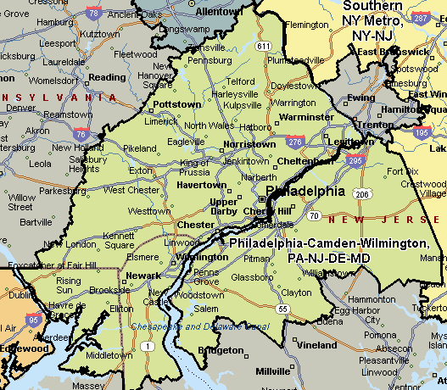
Allentown-Bethlehem-Easton, PA-NJ
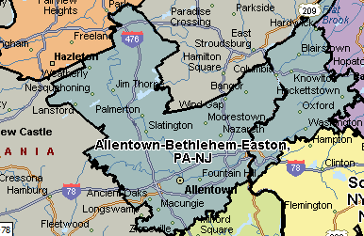
Scranton-Wilkes Barre, PA
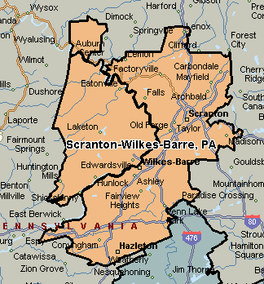
Youngstown-Warren-Boardman, OH-PA
