Cape Coral-Fort Myers, FL
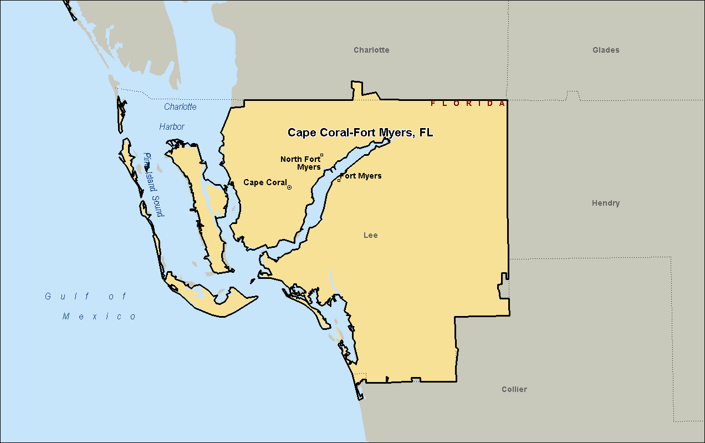

North Port-Sarasota-Bradenton, FL
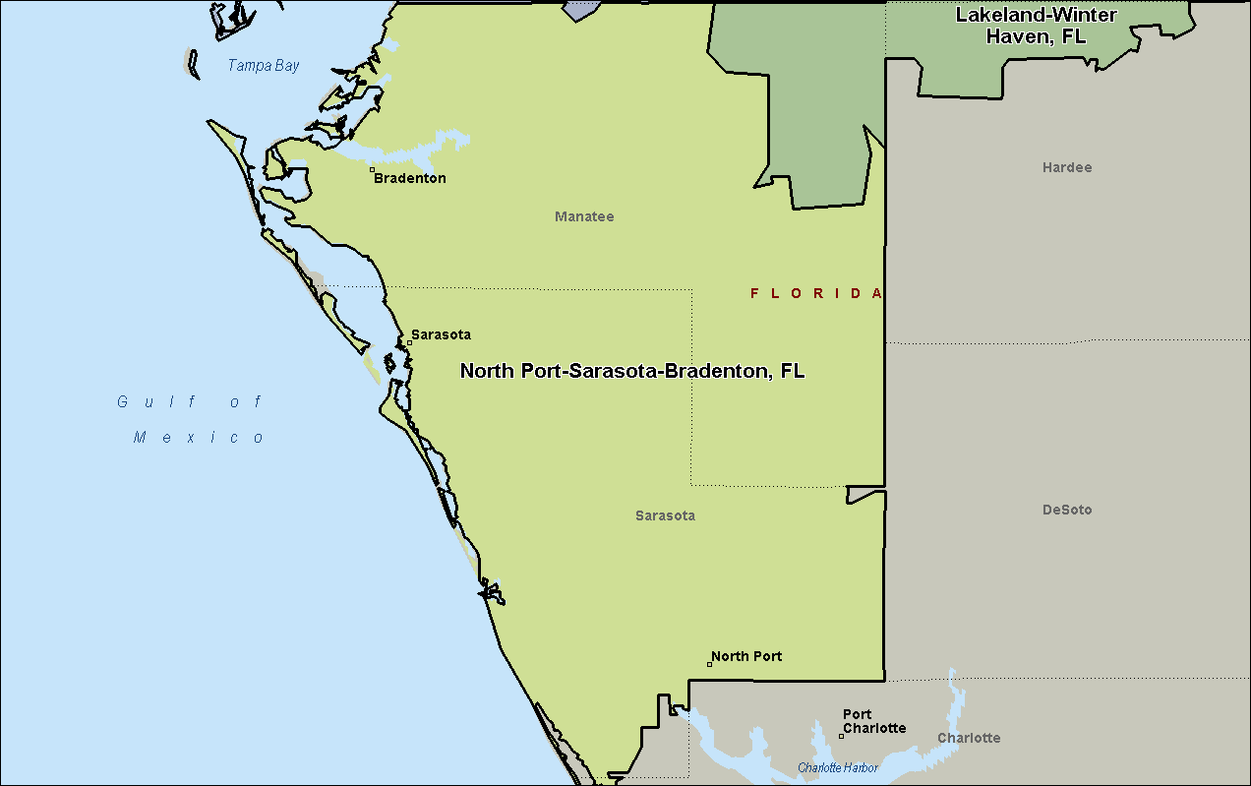

Tampa-St. Petersburg-Clearwater, FL
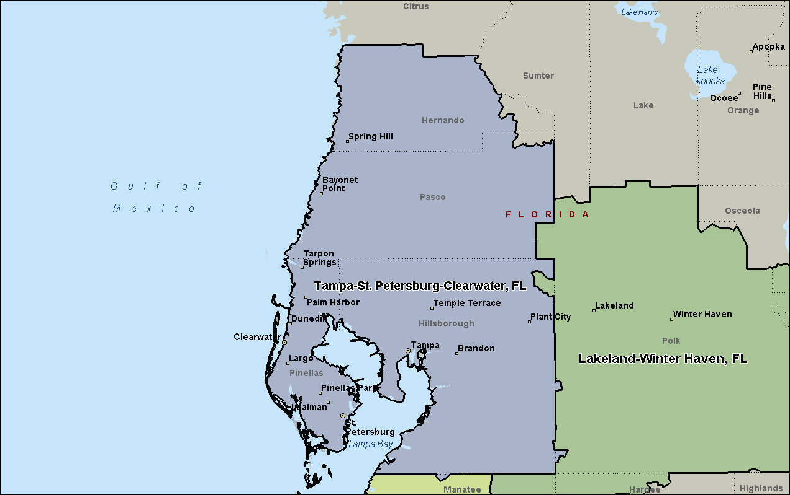

Lakeland-Winter Haven, FL
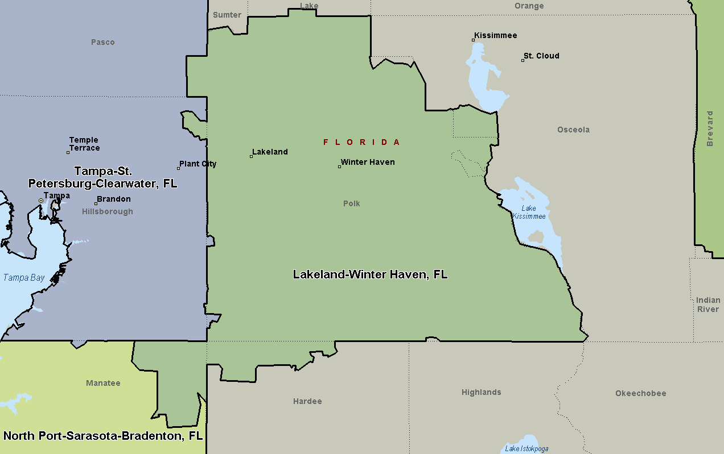

Palm Bay-Melbourne-Titusville, FL
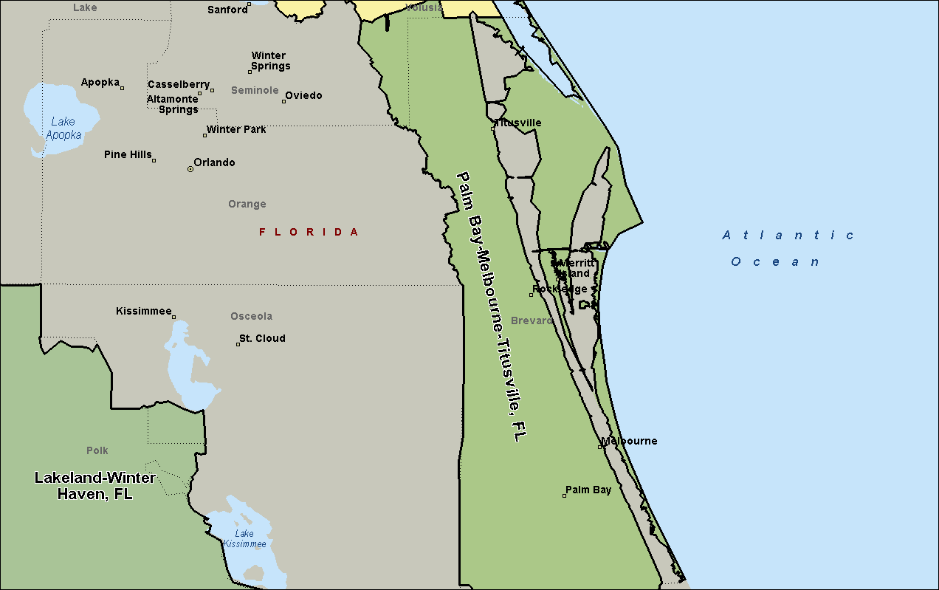

Deltona-Daytona Beach-Ormond Beach, FL
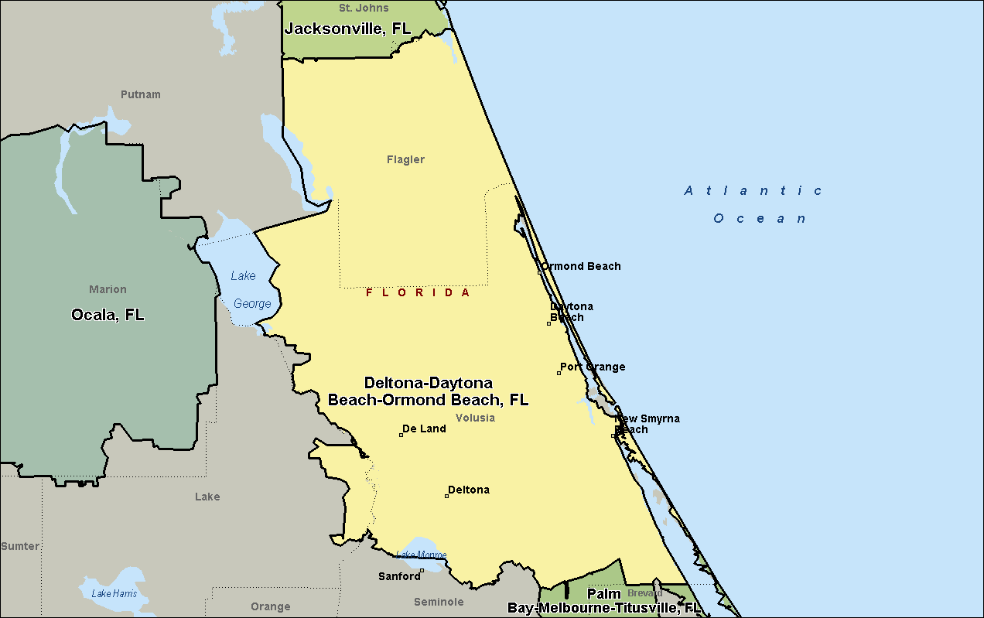

Ocala, FL
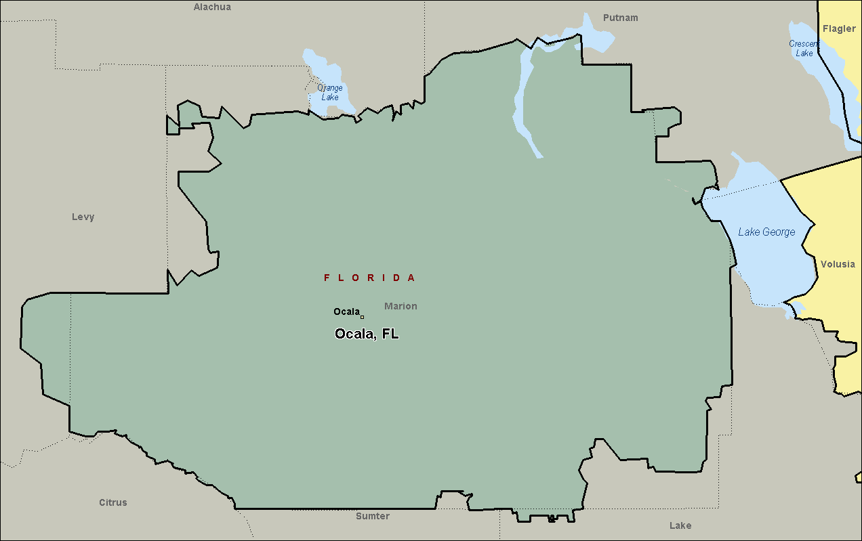

Jacksonville, FL
