Georgia CBA Maps
Augusta-Richmond County, GA-SC

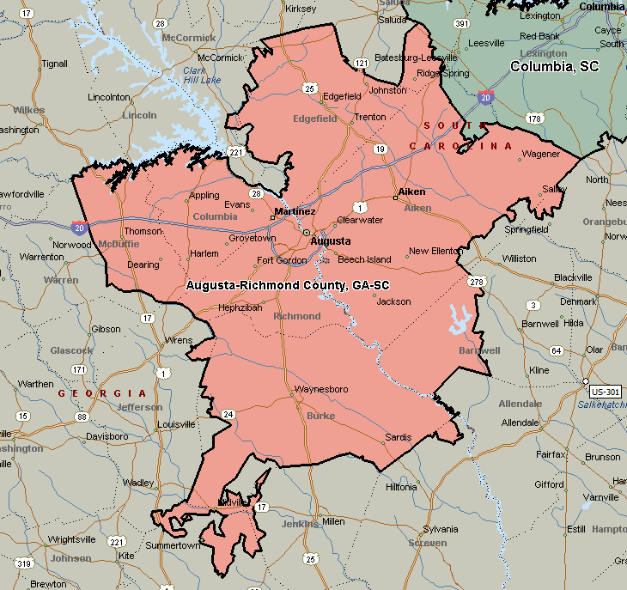

Atlanta-Sandy Springs-Marietta, GA
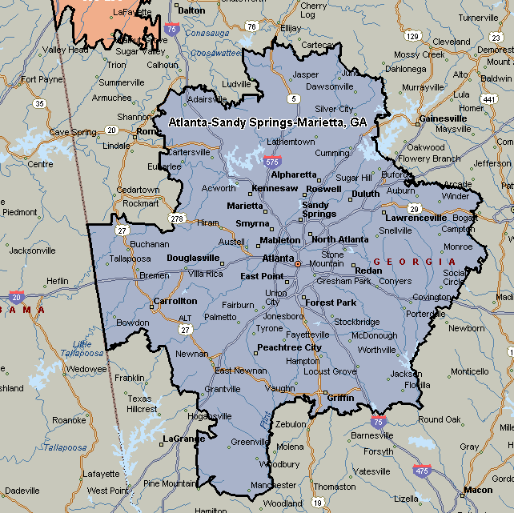

Chattanooga, TN-GA
