Suffolk County, NY
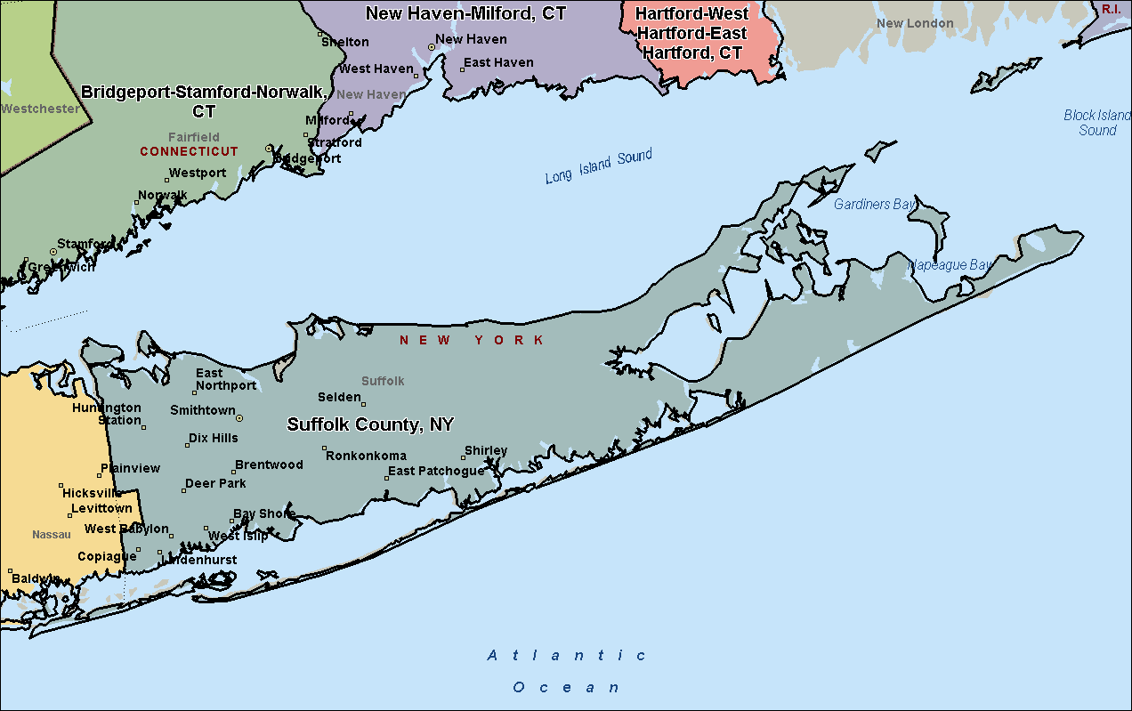

Nassau, Kings, Queens, & Richmond Counties, NY
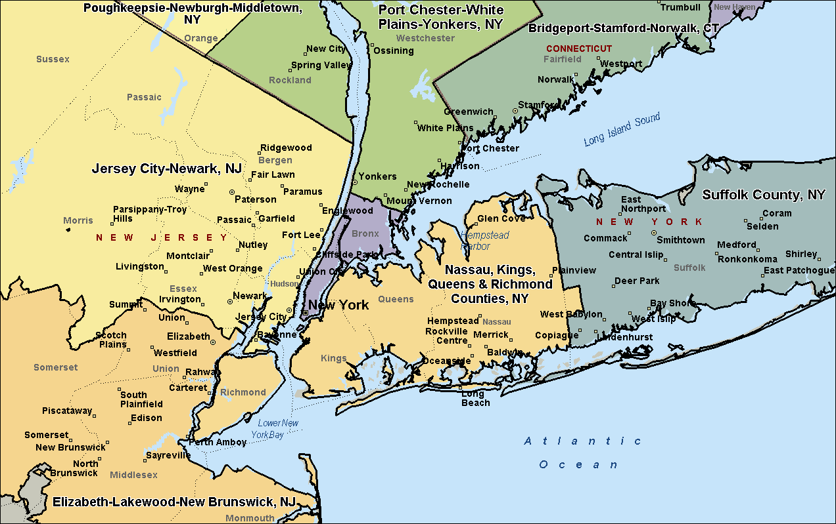

Bronx-Manhattan, NY
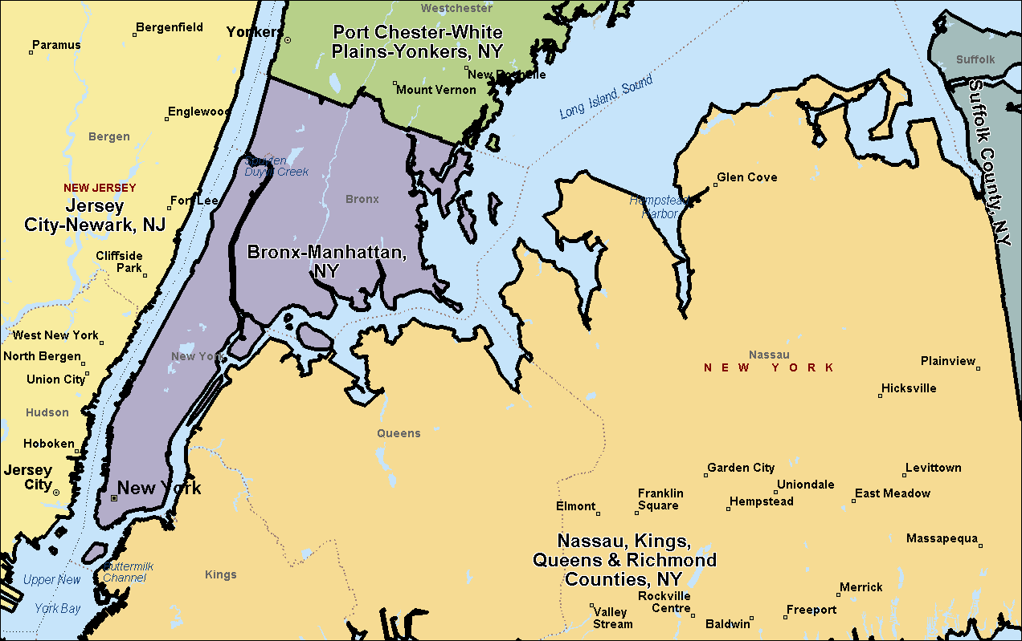

Port Chester-White Plains-Yonkers, NY
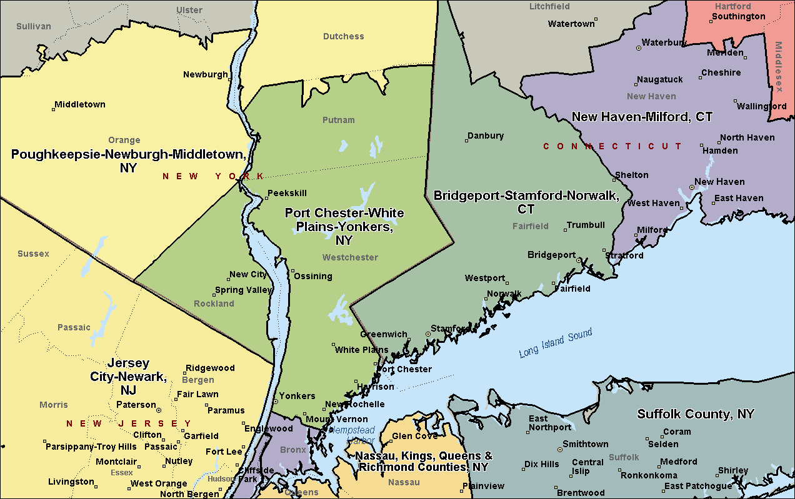

Poughkeepsie-Newburgh-Middletown, NY
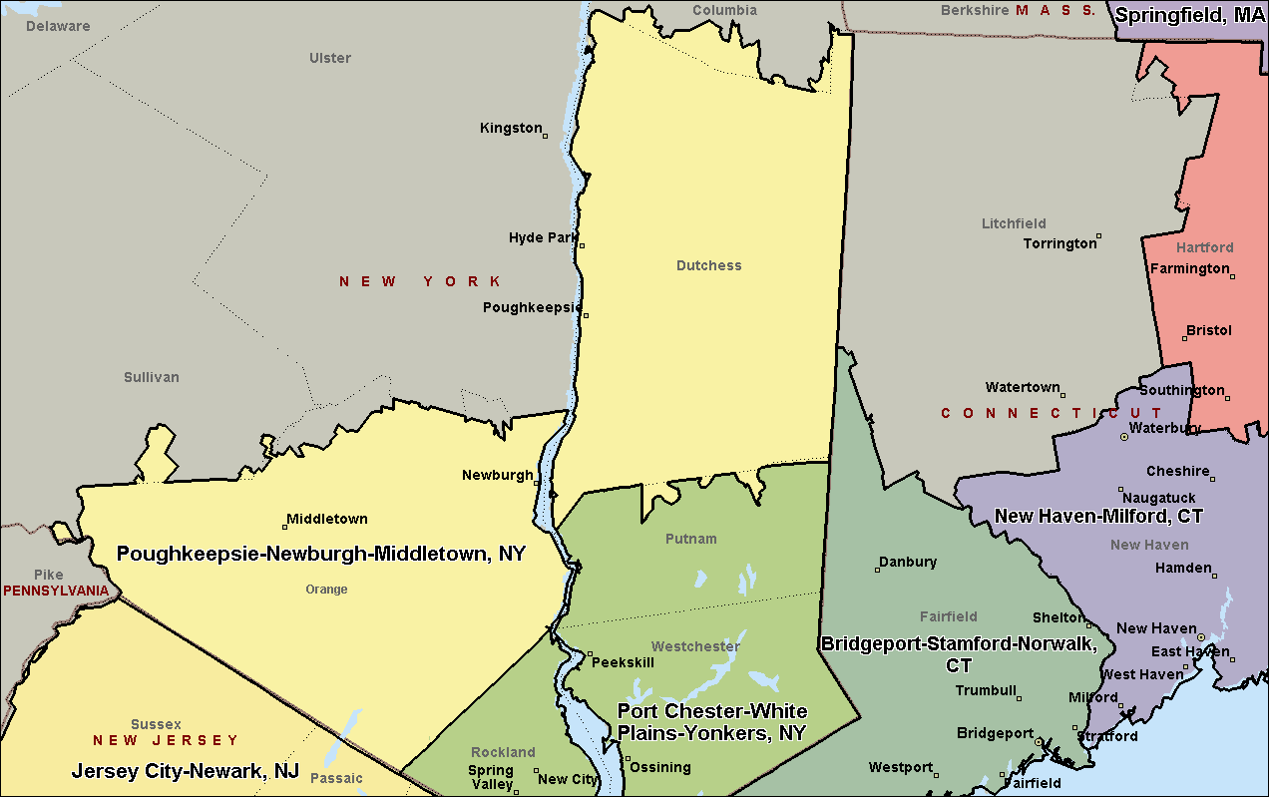

Albany-Schenectady-Troy, NY
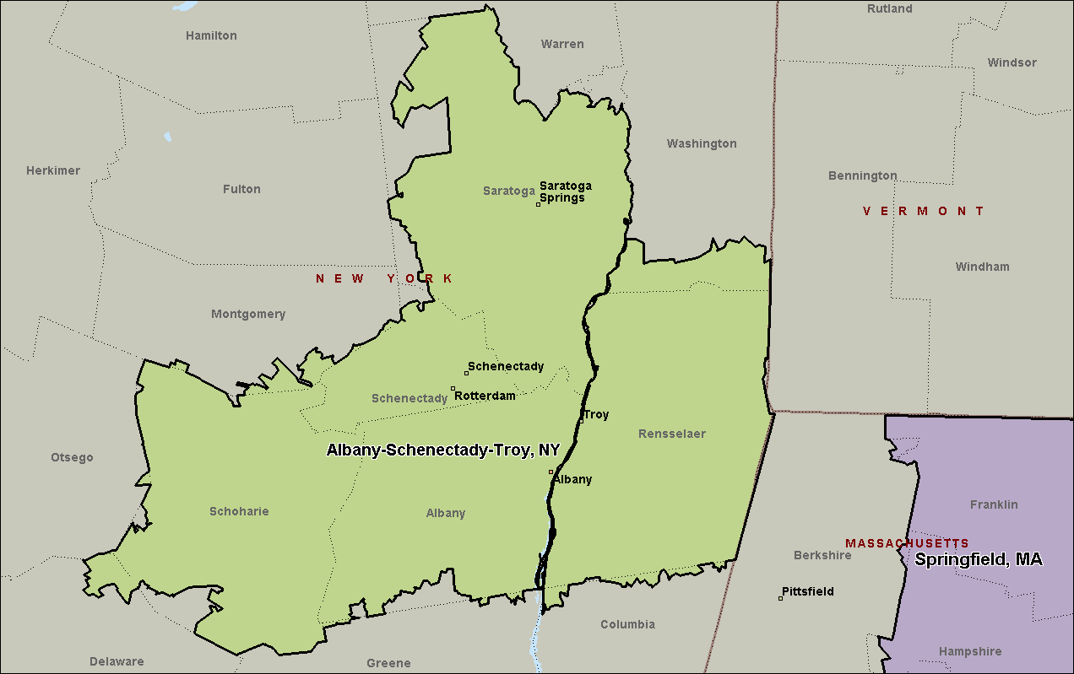

Syracuse, NY
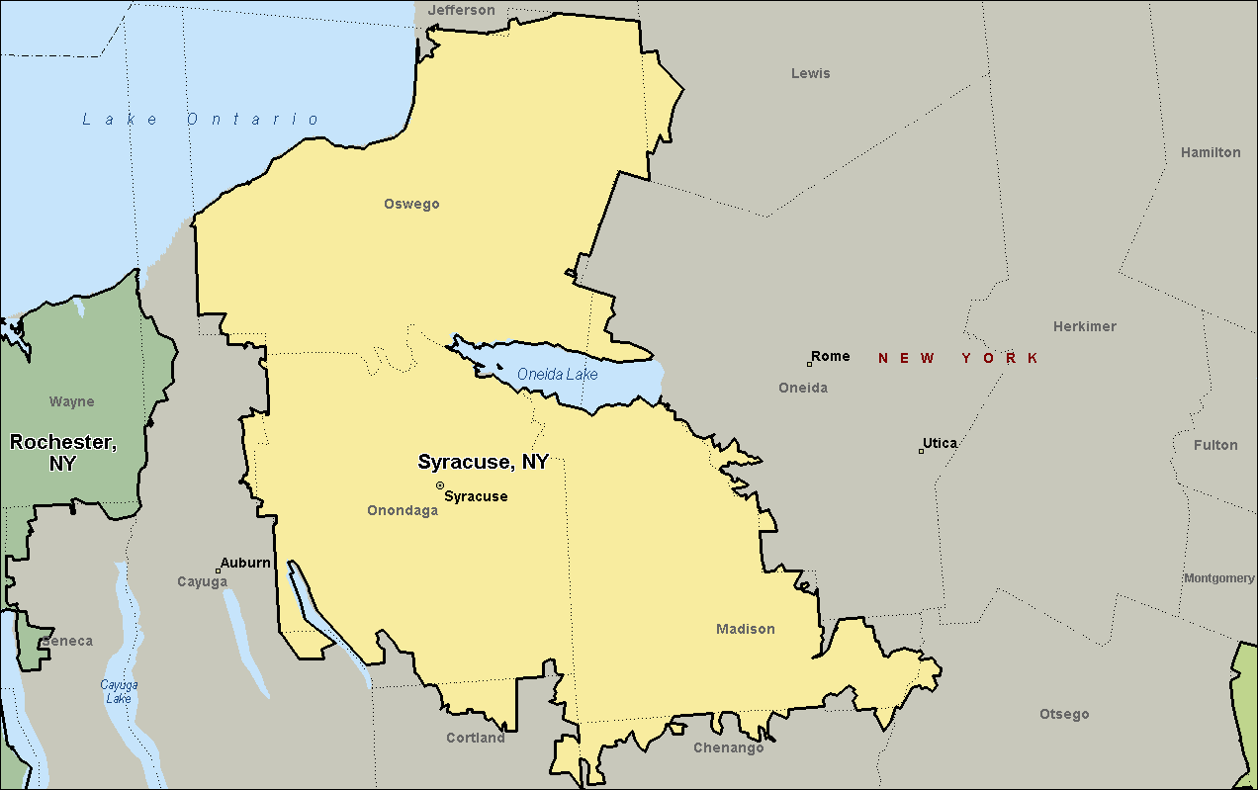

Rochester, NY
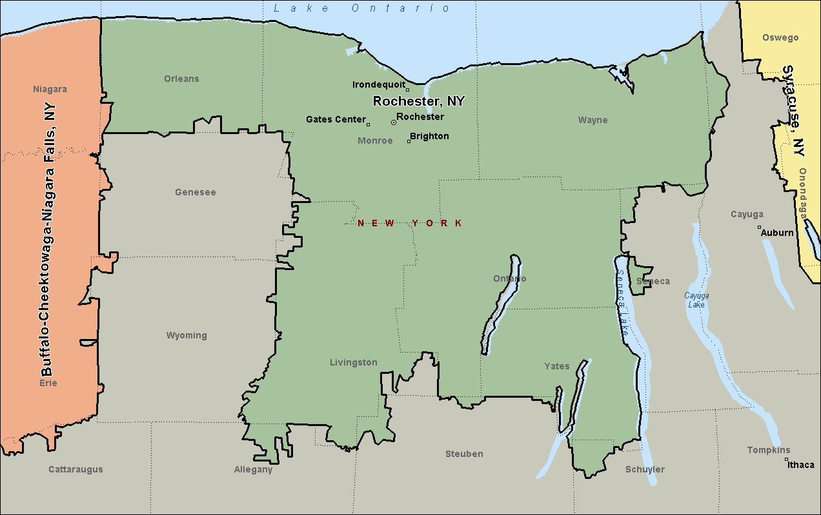

Buffalo-Cheektowaga-Niagara Falls, NY
