Virginia CBA Maps
Richmond, VA
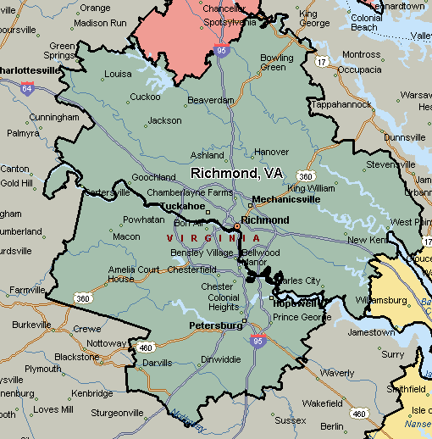

Virginia Beach-Norfolk-Newport News, VA-NC
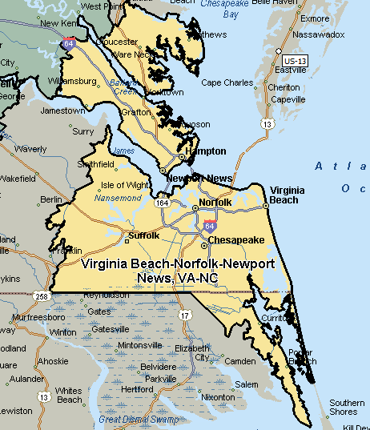

Washington-Arlington-Alexandria, DC-VA-MD-WV
