Indiana CBA Maps
Indianapolis CBA

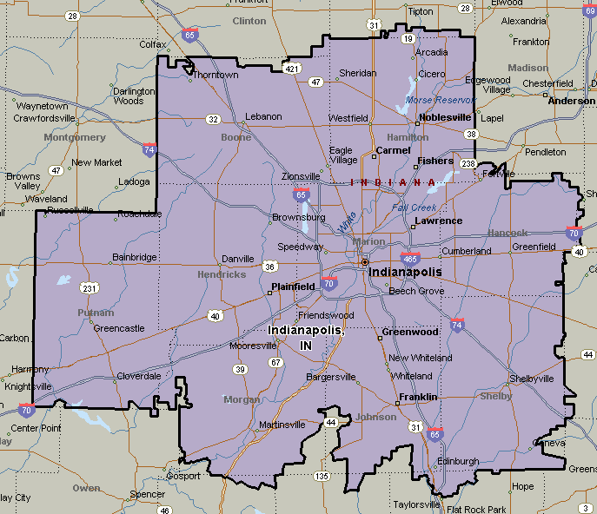

Indiana-Chicago Metro, IN
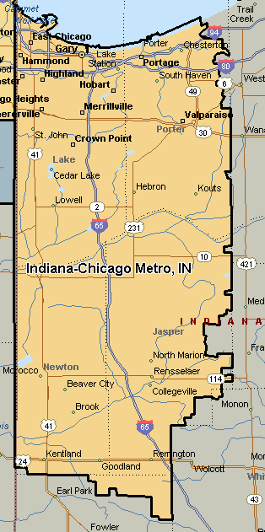

Louisville, KY-IN
