Florida CBA Maps
Jacksonville FL
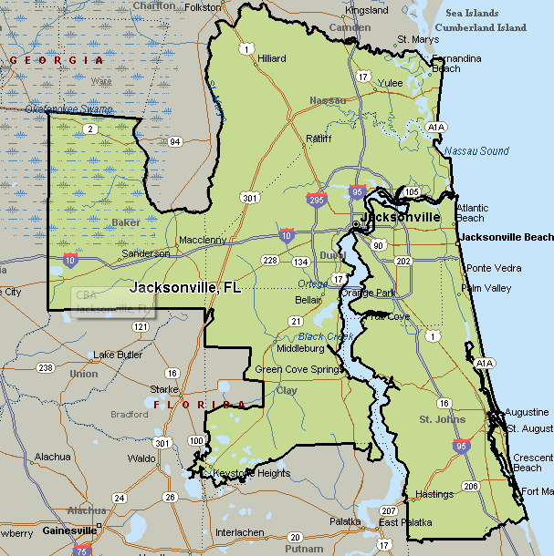

Ocala CBA
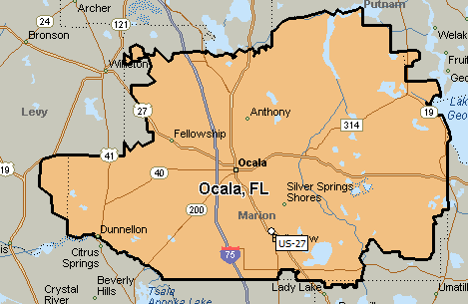

Deltona-Daytona Beach-Ormond Beach FL
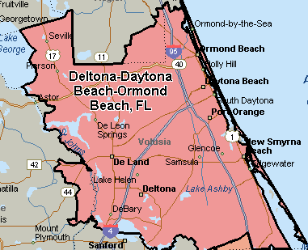

Lakeland FL
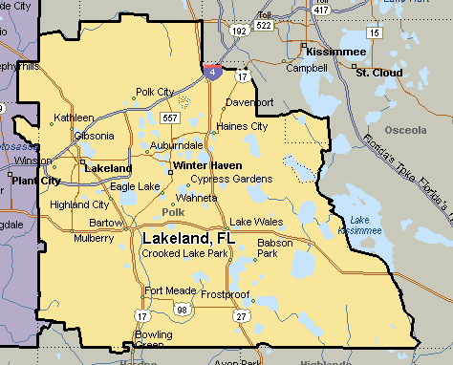
North Port-Bradenton-Sarasota, FL
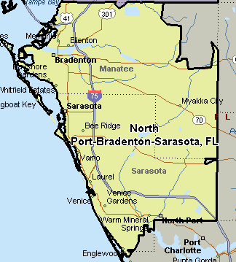
Tampa-St Petersburg-Clearwater FL
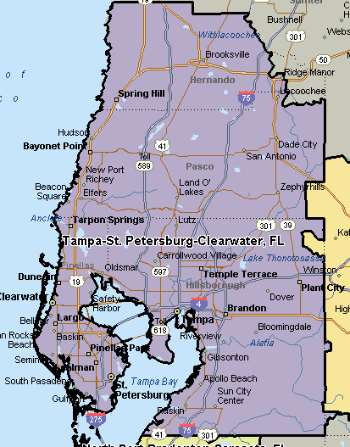

Palm Bay-Melbourne-Titusville, FL
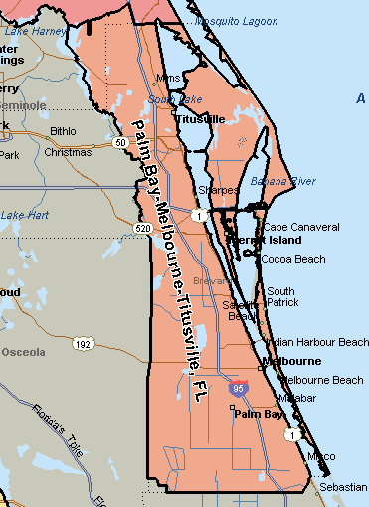
Cape Coral-Fort Myers, FL
